**North Point Church**

**Mobile Application User Guide**

**Getting Started**

To use the North Point Church app, you will first need to download it from either the IOS App Store or the Android Play Store.

1. Open the store for your desired platform (IOS or Android)
2. Search for “North Point Church”.
3. Download and install the app.
4. When it is installed you are ready to go.

**Familiarizing yourself with the interface**

**Home Page**

When you first open the app, you will be brought to this home screen.



While in the home screen you can click button to get to the other tabs.

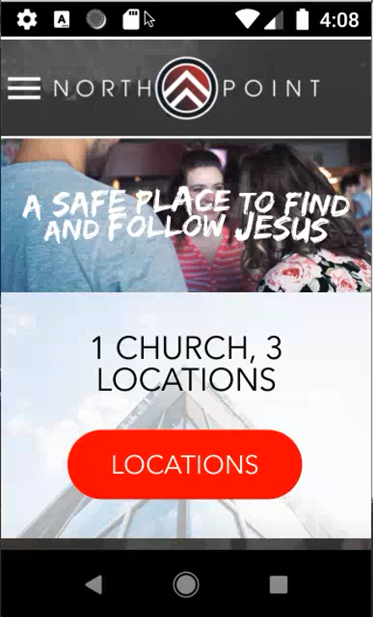

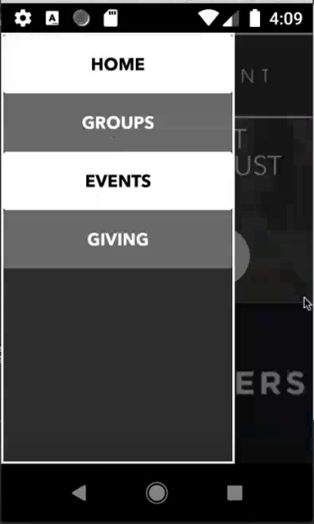

**Groups Page**

The groups page will have a list of all the groups that belong to the church.

**Events Page**

The events page displays any upcoming events held by the church.

**Giving Page**

The giving page will redirect you to where you may donate to the church at <https://northpointchurch.churchcenter.com/giving>.